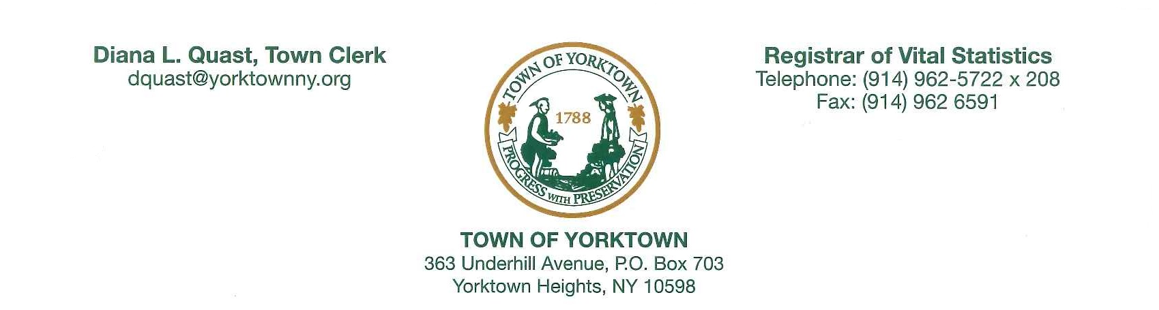
This is a resolution adopted by the Town Board of the Town of Yorktown at an emergency meeting held on Tuesday, May 28, 2024.

WHEREAS, the Town Board of the Town of Yorktown believes that leasing space on Town land for telecommunications purposes would enhance the health, general prosperities and economic welfare of the people of the Town of Yorktown;

WHEREAS, the Town desires to discontinue as parklands and lease at fair market value to Homeland Towers, LLC for a term not to exceed 30 years certain lands to make the necessary renovations and operate a radio transmission tower facility;

WHEREAS, the lands to be discontinued are described as follows:

ALL THAT CERTAIN PARCEL OF LAND SITUATE IN THE TOWN OF YORKTOWN, COUNTY OF WESTCHESTER AND STATE OF NEW YORK AND BEING A PORTION OF LAND CONVEYED TO THE TOWN OF YORKTOWN, A MUNICIPAL CORPORATION BY INSTRUMENT NUMBER 460060131 IN THE WESTCHESTER COUNTY CLERK'S OFFICE BOUNDED AND DESCRIBED AS FOLLOWS:

COMMENCING AT A POINT, SAID POINT BEING LOCATED ON THE NORTHEASTERLY BOUNDS OF GRANITE SPRINGS ROAD, SAID POINT ALSO BEING THE SOUTHEASTERLY CORNER OF TAX PARCEL 27.11-1-34, BEING OWNED NOW OR FORMERLY BY DOUGLAS AND KAREN ERICKSON, THENCE FROM SAID POINT OF COMMENCEMENT ALONG THE NORTHEASTERLY BOUNDS OF GRANITE SPRINGS ROAD N. 62° 39’ 43” W., 73.24’ TO THE POINT AND PLACE OF BEGINNING, THENCE FROM SAID POINT OF BEGINNING THROUGH THE SAID LANDS OF TOWN OF YORKTOWN, A MUNICIPAL CORPORATION, THE FOLLOWING THIRTEEN (13) COURSES AND DISTANCES:

- ON A CURVE TO THE RIGHT HAVING A RADIUS OF 30.00’ AND A LENGTH OF
CURVE OF 47.11’ WITH CHORD BEARING OF N. 17° 23’ 45.46” W., THENCE
2) N. 27° 20' 17” E., 170.00', THENCE
3) S. 85° 45' 34” E., 79.00’, THENCE
4) N. 20° 28' 43” E., 65.00’, THENCE
5) N. 40° 16' 31” E., 80.00’, THENCE
6) N. 69° 36' 12” E., 56.66’, THENCE
7) N. 82° 14' 39” E., 107.19’, THENCE
8) N. 07° 40' 18” W., 130.04’, THENCE
9) S. 82° 19' 42” W., 134.45’, THENCE
10) S. 36° 27' 01” W., 182.30’, THENCE
11) ON A CURVE TO THE LEFT HAVING A RADIUS OF 200.00’ AND A LENGTH OF
CURVE OF 136.86’ WITH CHORD BEARING OF S. 46° 33’ 46.98” W., THENCE
12) S. 27° 20' 17” W., 170.00', THENCE
13) ON A CURVE TO THE RIGHT HAVING A RADIUS OF 47.12’ AND A LENGTH OF
CURVE OF 30.00’ WITH CHORD BEARING OF S. 72° 12’ 10.93” W., TO A POINT
ON THE NORTHEASTERLY BOUNDS OF GRANITE SPRINGS ROAD, THENCE
ALONG SAID NORTHEASTERLY BOUNDS
14) S. 62° 39' 43” E., 110.00' THE POINT AND PLACE OF BEGINNING,
CONTAINING 51,109 SQ. FEET, MORE OR LESS.

WHEREAS, the revenues generated from said leasing would be used solely for the care of said parks and fields;

NOW, THEREFORE, BE IT RESOLVED, that the Town Board of the Town of Yorktown hereby issues this Home Rule request, effective as of May 28, 2024, in support and passage of Assembly Bill A10161A/Senate Bill S9212A.

AND BE IT FURTHER RESOLVED, that the Town Clerk is hereby authorized to transmit a home rule request form and a copy of this resolution to the home rule counsel of the state senate and state assembly.

________________________________
Diana L. Quast, Town Clerk
Master Municipal Clerk

Date: May 28, 2024

To: Diana L. Quast, Town Clerk

cc: Edward A. Lachterman, Town Supervisor
Gennelle MacNeil, Town Comptroller
Home Rule Counsel – State Senate
Home Rule Counsel – State Assembly
Adam Rodriguez, Town Attorney
file

